Present Simple: TO BE
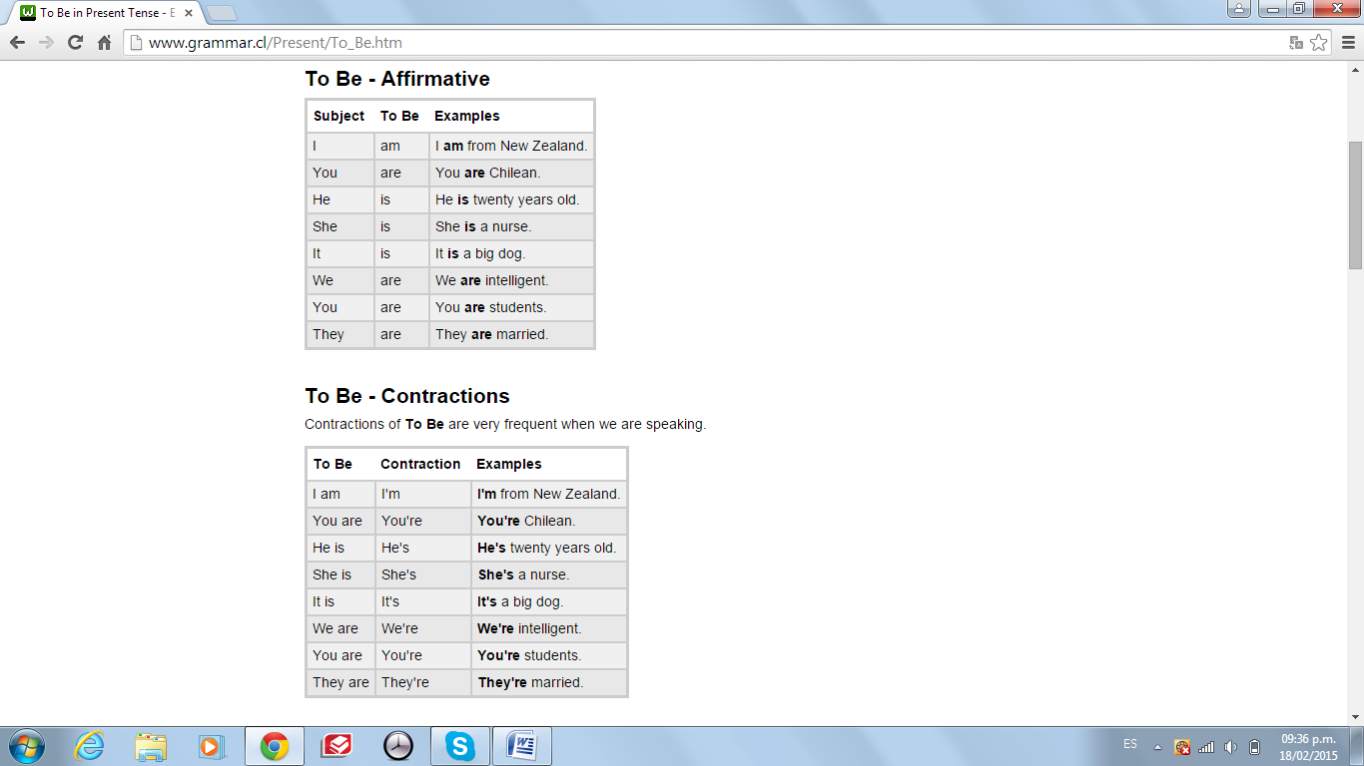
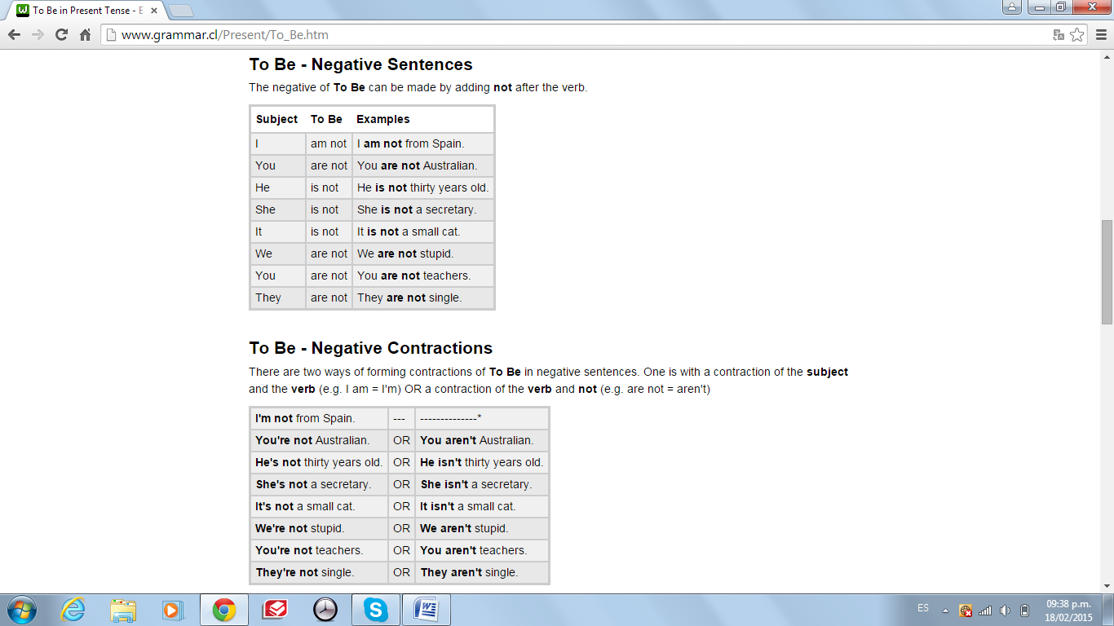
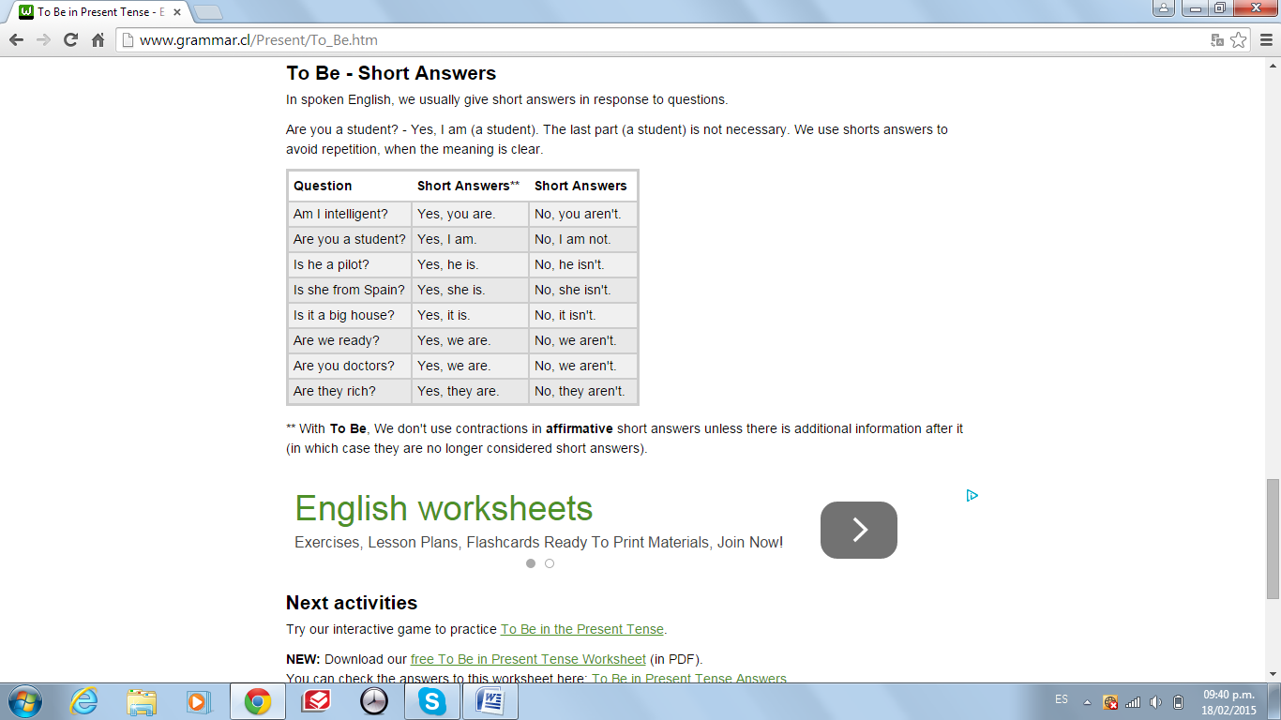
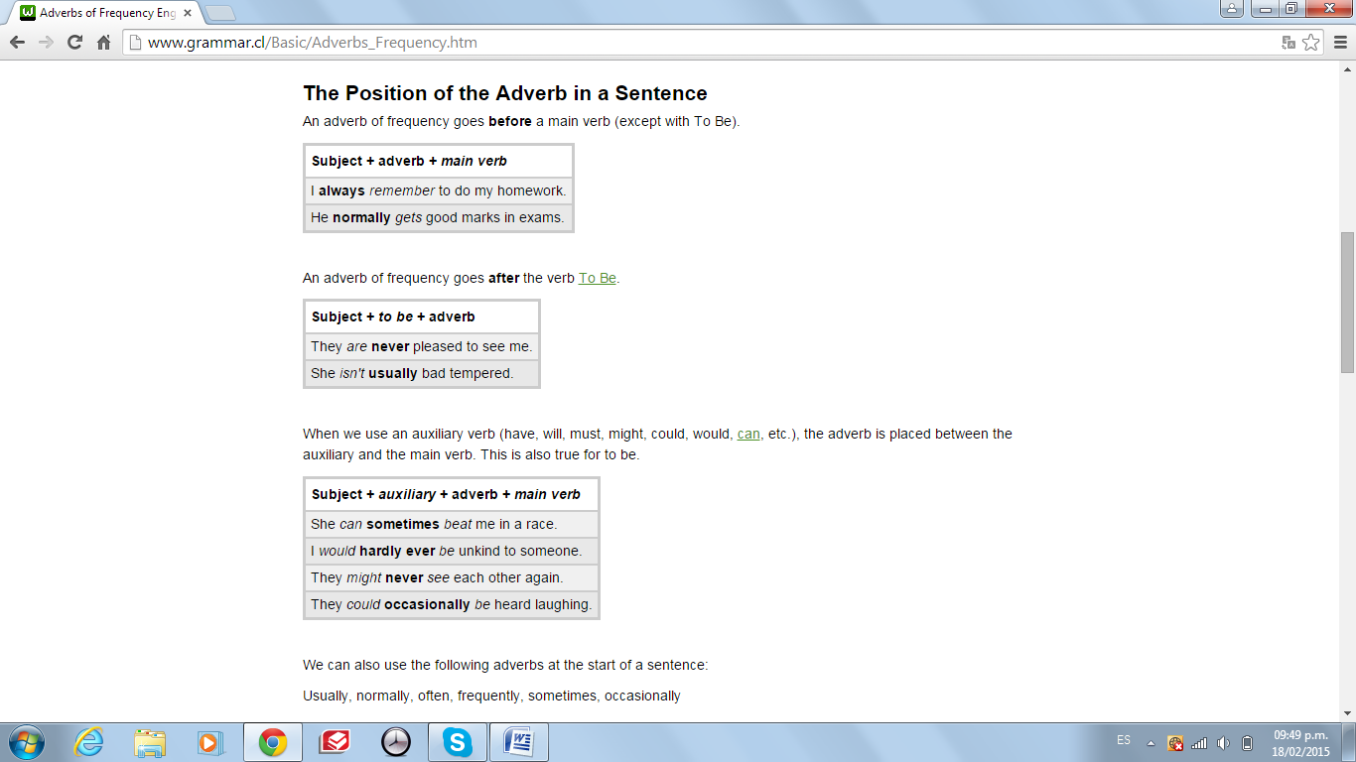



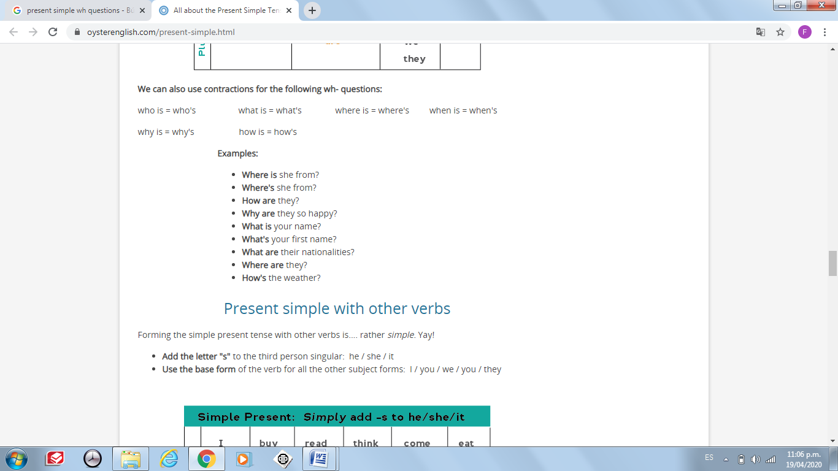
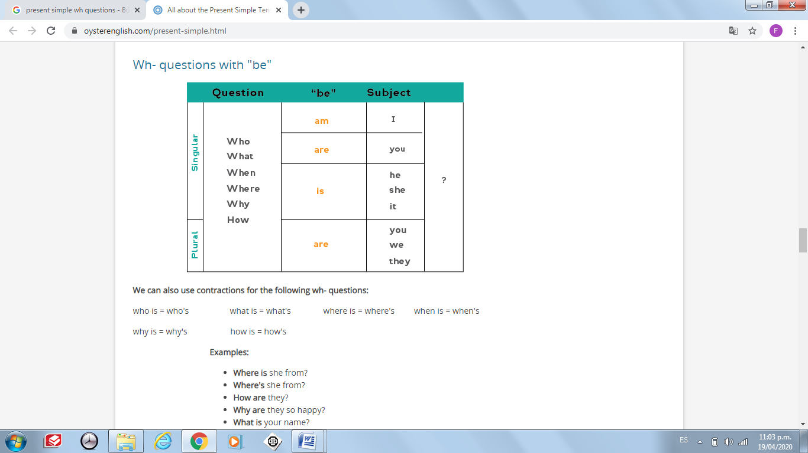


PRESENT SIMPLE
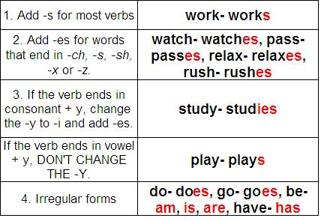
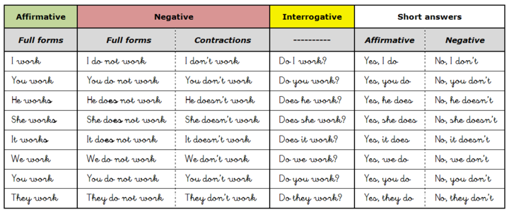

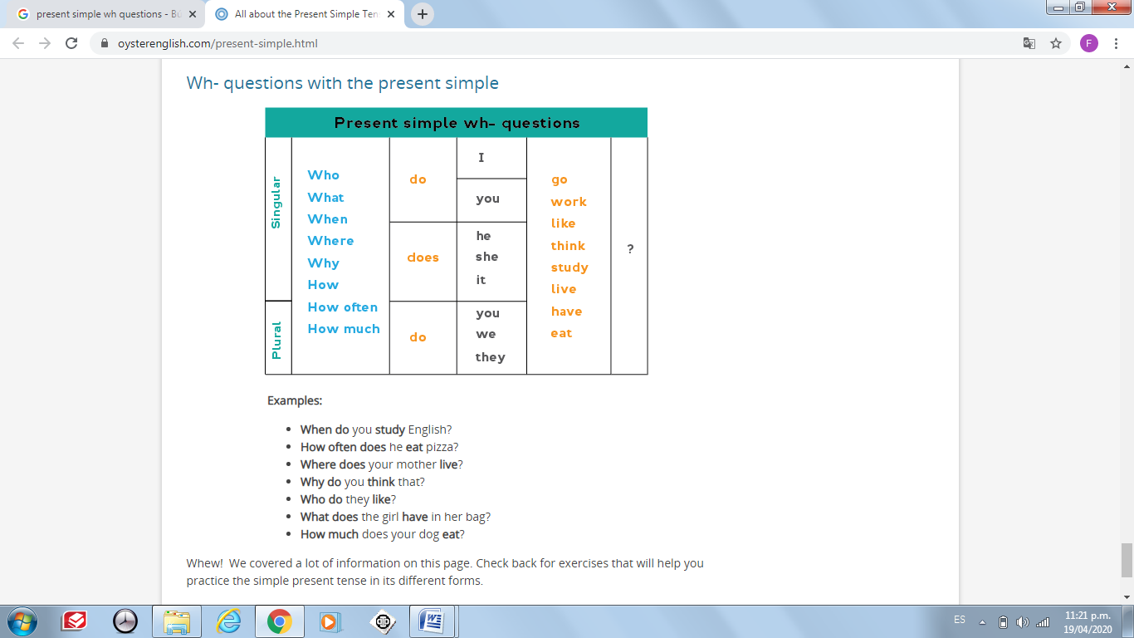


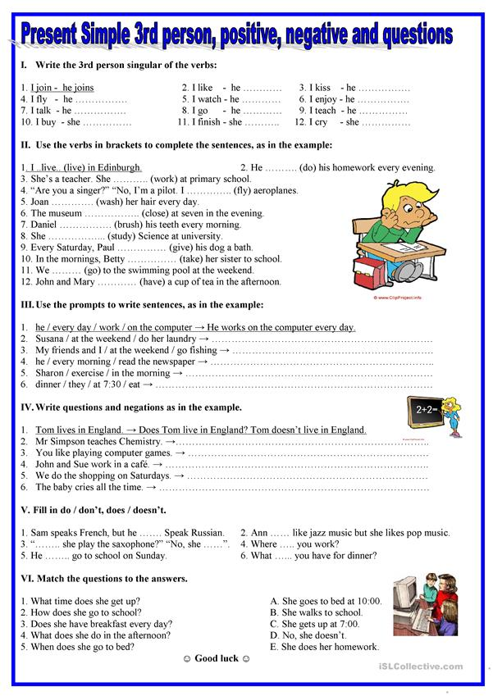
WH- QUESTIONS

- Use the information to make questions.
Example: The train arrives at ten o’clock. (what time) What time does the train arrive?
- They do their homework at night. (when) ……………………………………………………………………………………………….………
- Mr. Robertson comes to the party. (who) ……………………………………………………………………………………………….………
- The car is across the street from the house. (where) ……………………………………………………………………………………………….……………………………………………………………..
- I like the red blouse, not the blue one. (which) ……………………………………………………………………………………………….……………………………….
- She feels better when she take a nap. (how) ……………………………………………………………………………………………….…………………………………………………
- That is an English book. (what) ……………………………………………………………………………………………….………
- She talks to him for an hour. (how long) ……………………………………………………………………………………………….………
- He studies piano at the university. (what) …………………………………………………………………………………………………………………….………
- The check is for $5.50. (how much) ……………………………………..……………………………………………………………….………
- My parents have two cars. (how many) ……………………………………………………………………………………………….………..
- They come to visit us on Saturdays. (when) ……………………………………………………………………………………………….………………………………….
- The man with the white hat is my brother. (who) ……………………………………………………………………………………………….…………………………………
- I don’t get up early because I like to sleep late. (why) ……………………………………………………………………………………………….…………………………………………………………………
- They like to dance on weekends. (what) ……………………………………………………………………………………………….………
- The club is not far from their house. (where) …………………………………………..……………………………………………………………………….…
- Their favorite kind of music is Latin Jazz. (what)
……………………………………………………………………………………………….………………………………………………………………………..

